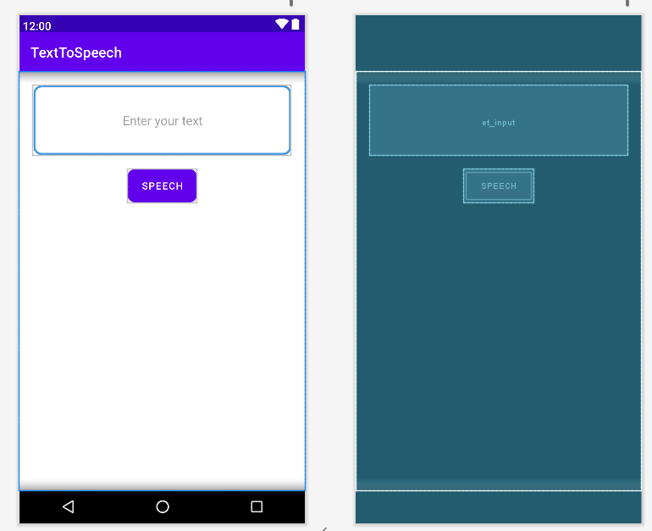

**MainActivity.java**

package com.avinash.texttospeech;

import androidx.appcompat.app.AppCompatActivity;

import android.os.Bundle;

import android.speech.tts.TextToSpeech;

import android.view.View;

import android.widget.Button;

import android.widget.EditText;

import java.util.Locale;

public class MainActivity extends AppCompatActivity {

EditText etinput;

Button btconvert;

TextToSpeech tts;

@Override

protected void onCreate(Bundle savedInstanceState) {

super.onCreate(savedInstanceState);

setContentView(R.layout.activity_main);

etinput=findViewById(R.id.et_input);

btconvert=findViewById(R.id.bt_convert);

tts=new TextToSpeech(getApplicationContext(), new TextToSpeech.OnInitListener() {

@Override

public void onInit(int status) {

if(status==TextToSpeech.SUCCESS){

int lang=tts.setLanguage(Locale.ENGLISH);

}

}

});

btconvert.setOnClickListener(new View.OnClickListener() {

@Override

public void onClick(View v) {

String message=etinput.getText().toString();

int speech=tts.speak(message,TextToSpeech.QUEUE_FLUSH,null);

}

});

}

}

**Activity_main.xml:**

<?xml version="1.0" encoding="utf-8"?>

<LinearLayout xmlns:android="http://schemas.android.com/apk/res/android"

xmlns:app="http://schemas.android.com/apk/res-auto"

xmlns:tools="http://schemas.android.com/tools"

android:orientation="vertical"

android:layout_width="match_parent"

android:layout_height="match_parent"

tools:context=".MainActivity">

<EditText

android:layout_width="match_parent"

android:layout_height="100dp"

android:gravity="center"

android:id="@+id/et_input"

android:hint="Enter your text"

android:textColor="@color/black"

android:background="@drawable/edit_text_background1"

android:layout_margin="20dp"

app:layout_constraintBottom_toBottomOf="parent"

app:layout_constraintLeft_toLeftOf="parent"

app:layout_constraintRight_toRightOf="parent"

app:layout_constraintTop_toTopOf="parent" />

<Button

android:layout_width="wrap_content"

android:layout_height="wrap_content"

android:layout_gravity="center"

android:id="@+id/bt_convert"

android:background="@drawable/edit_text_background1"

android:minWidth="100dp"

android:text="Speech"

/>

</LinearLayout>

**Edit_text_background1.xml:**

<?xml version="1.0" encoding="utf-8"?>

<shape xmlns:android="http://schemas.android.com/apk/res/android"

android:shape="rectangle">

<stroke android:width="3dp"

android:color="#4799E4"/>

<corners android:radius="10dp"/>

<solid android:color="@color/white"/>

</shape>

**OUTPUT:**

